Crain’s Cleveland Business

Cleveland Foundation commits $5 million to the Lake Link Trail project
By TIMOTHY MAGAW
Originally Published: August 19, 2014 11:00 AM Modified: August 19, 2014 2:37 PM
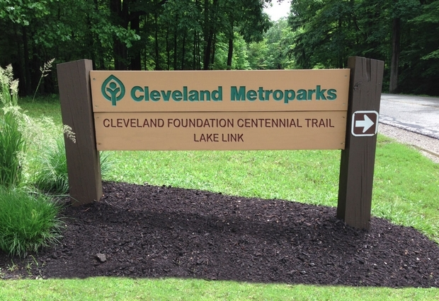
A rendering of the new sign to the entrance of the Lake Link Trail.
The Cleveland Foundation has committed $5 million toward a long-discussed project that dramatically will increase the public’s access to Lake Erie, connecting the riverfront to the lakefront, on the city’s West Side.
The grant — one of the foundation’s major grants in celebration of its centennial — will be given to The Trust for Public Land for the Lake Link Trail project, an effort that will require roughly $15 million to pull off, according to Pam Carson, Ohio director for the organization, a conservation group that launched in 1972 and has offices across the country.
“It’s a big deal for Cleveland,” Carson told Crain’s before the public announcement. “Everyone’s had a vision of this for many years.”
The trail will connect with the towpath at the southern end of the Scranton Peninsula and move along a 1.3-mile abandoned railroad right-of-way through the West Bank of the Flats. The trail will end at Wendy Park on Whiskey Island, which the Cleveland Metroparks took over earlier this year.
“It was an attractive project because it connected the river and the lake — two critical assets that in both cases have been undervalued in the past and we see as critical to the future of Cleveland,” Bob Eckardt, executive vice president of the Cleveland Foundation, told Crain’s.
In recognition of the gift, the pathway will be dubbed, “Cleveland Foundation Centennial Trail.” The gift was announced this morning during a community event at Rivergate Park in the Flats.
The Gund Foundation quietly kicked off the fundraising effort for the project last November when it gave $2 million to The Trust for Public Land, which is working with the Cleveland Metroparks, the city of Cleveland, Cuyahoga County, LAND Studio Inc. and others to increase the amount of parkland and trails that connect the city’s neighborhoods with Lake Erie. Last year, the Cleveland Foundation also contributed $200,000 toward the effort of transitioning the lakefront parks to the Cleveland Metroparks’ system.
“We are singularly focused on connecting the people to what they call our greatest asset,” Cleveland Metroparks CEO Brian Zimmerman told Crain’s.
The latest grant brings to $13 million in total commitments by the Cleveland Foundation over the last month toward what its officials describe as “creating high-quality public spaces” for the city’s residents. Last month, the foundation announced at $8 million grant in support of the ongoing efforts to remake Public Square. The grant dollars will be funneled to LAND studio, a local nonprofit that specializes in public space design, to support the Group Plan Commission’s efforts to remake the square — an area Cleveland Foundation CEO Ronn Richard described at the time as the “ultimate symbol of a place for people.”
The Lake Link Trail and Public Square grants are part of the foundation’s centennial legacy grant series launched in September 2012 with a $10 million commitment to support Case Western Reserve University’s new medical education building, which will be built on the Cleveland Clinic’s sprawling campus.
Last year, as part of the transformative grantmaking push, the foundation also announced a $10 million grant to create a local Encore program — an effort designed to mobilize those 50 years of age and older for the betterment of their communities.

